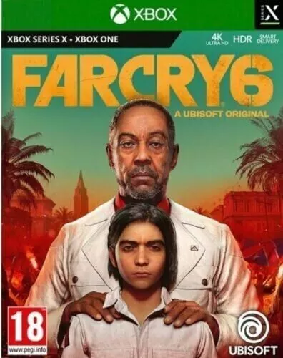

*Far Cry 6:*

1️.**Massive Open-World in Yara**

* Explore **Ubisoft’s largest Far Cry map**, featuring **jungles, cities, beaches, and military zones**.
* Use guerrilla warfare tactics to overthrow **Antón Castillo’s dictatorship**.

2️.**Customizable Weapons & "Supremo" Abilities**

* Craft and modify weapons, from **makeshift flamethrowers** to **CD-launching guns**.
* Equip **Supremo backpacks** with abilities like **rocket barrages and EMP blasts**.

3️. **Animal Companions ("Amigos")**

* Recruit **Chorizo (a cute yet deadly dachshund), Guapo (a tough crocodile), and more** to aid in combat.

4️. **Intense Villain – Antón Castillo**

* Played by **Giancarlo Esposito**, Castillo is a **charismatic yet brutal dictator**, making him one of Far Cry’s most memorable villains.

5️. **Full Co-Op Campaign**

* The entire story is **playable solo or with a friend in online co-op**, allowing **strategic mission coordination**.